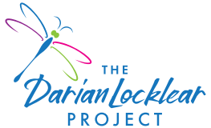
Thank you for your interest in The Darian Locklear Community Care Grant! We are happy to help support Livingston County families who are struck with a family tragedy or crisis.
Beginning in 2020, when COVID-19 hit hard and so many families were in crisis mode, The Darian Locklear Project saw a continuing necessity to help those in need. We are able to help others through the generosity of our supporters and sponsors. Instructions for applying are below:
Complete this application and email it to: thedarianlocklearproject@gmail.com
Requester Name Date
Email Address | Cell Phone

Recipient Name:
Address
City Brighton |  | State MI |  | ZIP Code 48116
Employer
Do you authorize the DLP to share the recipient’s story? (Yes / No)

Describe circumstances for needing financial support:

